# **Week 8 –** **Network Analysis**

# **Exercise: Centrality Analysis**

Given a undirected network as following:

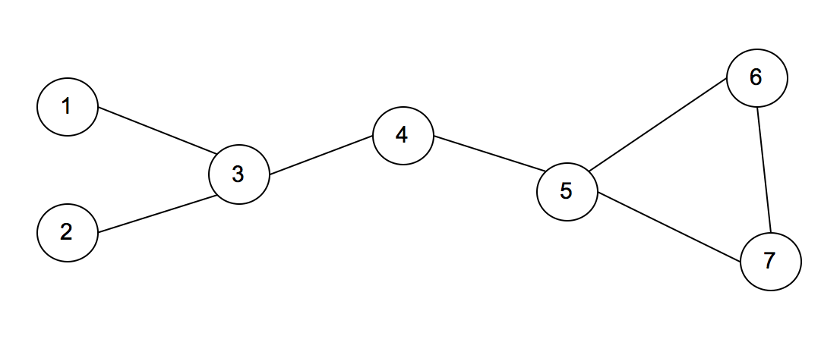

* Calculate Degree centrality scores of each node in the network above, and complete the table below

|  |  |
| --- | --- |
| **Node** | **Score** |
| 1 | 1 |
| 2 | 1 |
| 3 | 3 |
| 4 | 2 |
| 5 | 3 |
| 6 | 2 |
| 7 | 2 |

* Calculate Betweenness centrality scores of each node in the network above, and complete the table below

|  |  |
| --- | --- |
| **Node** | **Score** |
| 1 | 0 |
| 2 | 0 |
| 3 | 9 |
| 4 | 9 |
| 5 | 8 |
| 6 | 0 |
| 7 | 0 |

* Calculate PageRank centrality scores of each node in the network above, and complete the table below

|  |  |
| --- | --- |
| **Node** | **Score (15 step)** |
| 1 | 0.09039 |
| 2 | 0.09039 |
| 3 | 0.169713 |
| 4 | 0.166496 |
| 5 | 0.1955 |
| 6 | 0.144056 |
| 7 | 0.144056 |

* Suppose the above network refers to friendship network.  Each node represents a person, and each edge represents friendship between the persons at ends.  If you are interested in finding the most popular person in the network, which centrality measure is the most appropriate?  Give the answer with reasons why it is the most appropriate.

PageRank is the most appropriate centrality measure in this case.

PageRank works by counting the number and quality of friendships to a person to determine a rough estimate of how important the person is.

* Suppose the above network refers to information flow network of an organization. If you are interested in finding the section that can most frequently control information flow in the network, which centrality measure is the most appropriate?  Give the answer with reasons why it is the most appropriate.

Betweeness centrality is the most appropriate centrality measure

Because:

To control information flow, a node should be between other nodes because the node can interrupt information flow between them.